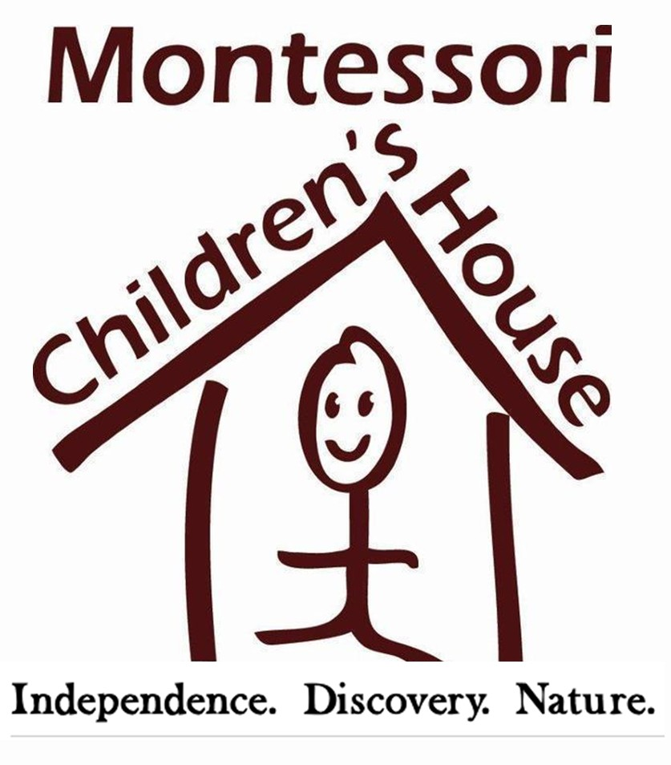

FOR RELEASE: Contact:
September 14, 2017 Georgie Hockett, Marketing/PR
georgienick@hotmail.com
206. 852. 2911
MCH TEACHER TO SPEAK AT SEATTLE’S GEEKGIRLCON

REDMOND, WA – Montessori Children’s House (MCH), an AMS-accredited Montessori school, is proud to have their Environmental Specialist, Ali Yeates, join a panel of speakers featured in Seattle’s STEM-convention targeted towards girls, GeekGirlCon.

GeekGirlCon is an organization that empowers women and girls to pursue their passions—whether they love science and technology, comics, literature, gaming, “or anything else!” according to their website. “Everybody is a geek at heart, in one way or another,” convention organizers said.

Ali Yeates has been with Montessori Children’s House in Redmond for two years, and has been a long-time advocate of girls in tech …and nature. Before joining MCH, Ali worked with the National Park Service as an Outreach and Education Ranger, Interpretative Ranger and Co-Director of the Yellowstone Youth Conservation Corps in Yellowstone and Big Bend National Parks. Ali spent four years teaching in Expeditionary Learning at two local charter schools and was the Director of the Girls in Research, Invention, Technology and Science Program. In addition to being a part of the MCH education team, Ali is a Candidate for Master's in Environmental Management.

When one of her student’s parents, Kari Ramadorai, invited Ali to be a part of the “Science Isn’t Scary” panel, Ali jumped at the chance. “We’re going to discuss how to incorporate science into everyday activities and conversations with the goal of empowering young women to see themselves as scientists,” she said.

The rest of the Science Isn’t Scary panel will be made up of female scientists and other Montessori educators.

The panel including MCH’s Ali Yeats will speak at GeekGirlCon on September 30, 2017 from 4:00 – 5:00 p.m. GeekGirlCon takes place at The Conference Center, located at 8th and Pike in downtown Seattle, WA, right across the street from the Washington State Convention Center. Tickets to GeekGirlCon are available online.

# # #

ABOUT MONTESSORI CHILDREN’S HOUSE
Founded in 1987, Montessori Children's House is an American Montessori Society accredited school in Redmond and Sammamish. MCH is committed to an authentic Montessori education with an emphasis on nature. The serene, five-acre campus in a farm-like setting connects students to their natural environment and encourages individualized learning. Visit MCHkids.com or MCH’s Facebook page to learn more.

